Bills Splitter is an application for splitting bills evenly. Useful when a group cannot agree on the amount they should pay.

Planning and Approach
I chose to approach this with the idea that there will be someone wanting to split bills evenly between all parties involved. With this idea, I decided to create the most functionable and robust feature dedicated to splitting the bills and keeping track of all the bills currently active. I keep the GUI simple as it is not the main approach for my vision.

Tech Stack and the Reasoning
Frontend: Python
- A straightforward programming language that is understandable by most developers
- Most comfortable to work with
Backend: Python
- Easily understandable and highly intuitive to work with
Database: SQLite, Python’s built in library
- Useful for local databases that does not need internet to work
- Very straightforward, much like the programming language that it is in
GUI: Tkinter, Python’s built in library
- Simple and efficient way of creating a user interface
- Have an old-school vibe to it
- Have prior experience in using this library

Core Features
- Split bills
  - Able to split bills evenly

- Data storage
  - Store the bill splitting information for viewing in Expense Trackers
Flowchart
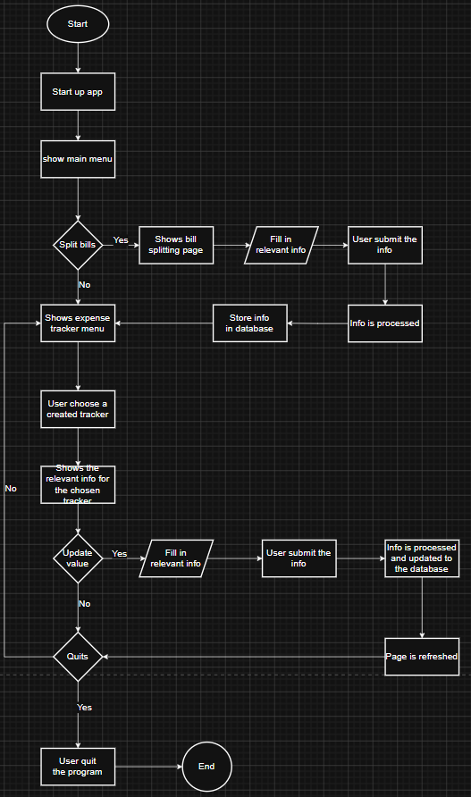
Wireframe
